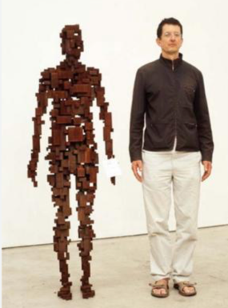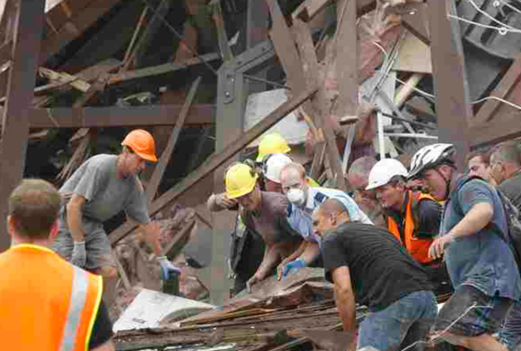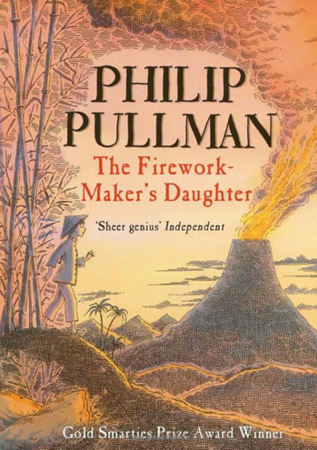

**Maths**

We will kick off Spring 2 with all things Fractions, for 4 weeks.

Then, we will tie off the end of the Spring term, with Year 3s exploring Mass and Capacity, while Year 4s interrogate decimals.

**Science -** We will compare and group together different kinds of rocks on the basis of their appearance and simple physical properties.

We shall recognise that soils are made from rocks and organic matter.

**Computing**

Data logging will be our skill for this unit. We will also learn to use technology safely, respectfully and responsibly, recognising acceptable and unacceptable online behaviour.

**RE**

Why do Christians call the day Jesus died ‘Good Friday’?

**Butterflies – Year 3 and 4**

**Spring 2 - Term 2**

**Key Question:**

Why do some earthquakes cause more damage than others?

**Geography & History -** We begin our journey, by meeting Paula and Richard and hearing their account of what happened on the 22nd of February 2011 when “*the ground beneath our feet shook”.*

-Why does New Zealand have so many Earthquakes?

- Why don’t the largest earthquakes always cause the most death and destruction?

- Why do most volcanoes happen in the same places as earthquakes?

Disciplinary Knowledge: compass points, atlas reading skills and tectonic plate boundary locations, on the world map.

**Art –** We will learn about and take inspiration from, UK artist, Anthony Gormley.

We will expand our artistic skills, by developing 2-dimensional art design, into 3 dimensional sculptures.

**Activate Curiosity**

Why won’t Paula and Richard forget 22 February 2011?

**Extreme Earth – STOKE GABRIEL PRIMARY**

**English**

We will be examining the literary techniques of Philip Pullman’s ‘The Firework – Maker’s Daughter’, to develop our own fictional story, set in another culture. Within our fictional story, our character will write a letter.

**PE -** Butterflies will have the opportunity to experience a Handball event, using their new skills developed in class.

ACTIVATE CURIOSITY DISCUSS AND DISCOVER LET’S DO IT DIG DEEPER SHARE, CELEBRATE AND REFLECT