**PSHE**

Our theme this ½ term is Being me in my World.

**Art**

Our theme this half-term is plants and flowers. We will learn how to use pencil, colour, Hapa Zome printing, sculpture and paper modelling to create quality artwork that shows progression in their skills. The children will also have the opportunity to explore the work of India Flint, Alexander Calder, David Oliveira and Henri Rousseau.

**Maths**

Both year groups will be focusing on place value. Year 6 will be ordering and rounding up to 10 million; Year 5 will be up to 1 million. We will be exploring below zero and looking at negative numbers in context. We too will be improving our four operations of adding, subtracting, multiplying, and dividing.

**Geography**

Our topic for this half-term is ‘Where is here?, What is *here* like?’. This will see us taking an in-depth look at Stoke Gabriel and its place within the UK. By developing our map and fieldwork skills, along with our knowledge of human and physical geography, we will produce an A3 poster to showcase our findings.

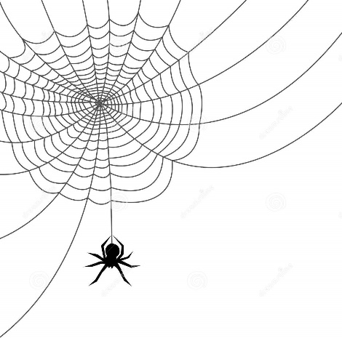

**English**

We shall be writing two narratives this half-term. The first will focus on mystery texts where we will convey mystery by including suspense-filled writing that includes short sentences, cohesive devices, and well-chosen vocabulary.   
The second text is Where My Wellies Take Me by Michael & Clare Morpurgo. This links to our Enquiry Journey work about our local area. We will write our own recount of Where My Wellies Take Me.

**RE**

We are focussing on the religion of Hinduism. By learning about their God and the many representations that it can take, along with key information about the religion, we can work towards understanding and forming opinions for ‘Why do Hindu’s want to be good?’

**Spiders Planning Map – Autumn Term 1**

**Science**

We will learn to become Taxonomists by categorising living things. We will design our own ‘curious creature’ and classify it based on its characteristics. We will learn about micro-organisms and conduct an investigation into the growth of mould on bread. Furthermore, we will use play dough to create a new single celled micro-organism and explain how it is classified and why.

**Music**

We are learning the song ‘Happy’ by Pharrell Williams and will work towards singing together as a whole class, in time and in tune. To help with this, we will be learning about the beat and the rhythm of the song, and how this can help us to stay in time with each other.

**PE**

This half-term we are learning about invasion games through tag-rugby. Beginning with passing, movement and attack .v. defence activities that progress the skills needed to move into competitive game situations. Spiders class will develop their passing, catching and throwing skills, along with their running, balance and agility.

**Computing**

We will be learning about internet communication and how systems all over the world can communicate with each other. Just like humans use their listening and speaking skills to communicate, computers ‘listen’ and respond in a very similar way.