Daily | Weekly | Termly
- Read  The most important activity you can do is read. Ideally, 20 minutes or more, but even if it’s just a few pages, you will expand your vocabulary and learn something new. Carry a book; you never know when you might get the opportunity!    - Bug Club books need to be read at least twice for fluency.  - AR quiz at home, or at school.  QR:   | - Practice your weekly spellings.  Tests are on Wednesdays. You’ll find the weekly spelling list on the school website, class pages, Butterflies, or use the QR:  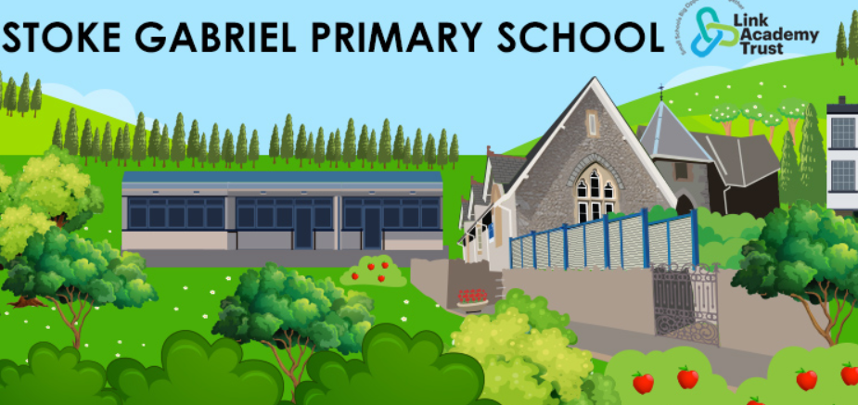    - TTRS practice/multiplication practice.  Multiplication knowledge underpins lots of number knowledge, which will accelerate your progress in maths! | Let’s get this project in early! As you know, my advice is to aim to get it in before the deadline, it’s a good habit to develop.  Homework Project  Overleaf, you will find a eco-living survey form. How could we live more sustainably? At the heart of a geographical world view that sees the interrelationship of people with the environments as crucial study, lies the concepts of sustainability and sustainable development. Homework: pupils are asked to survey their homes and using their findings, to develop a Personal Sustainability Action Plan to improve sustainability in their homes.  Deadline: 07.02.25  


