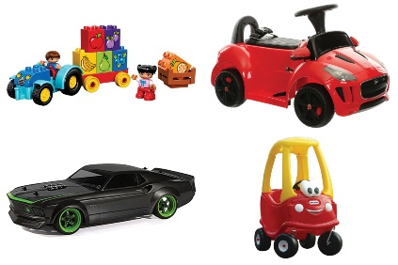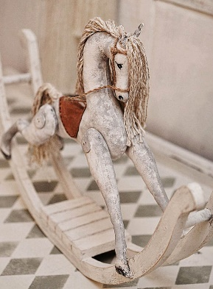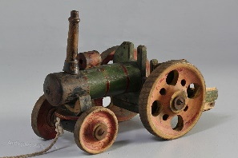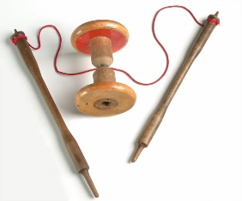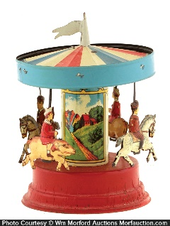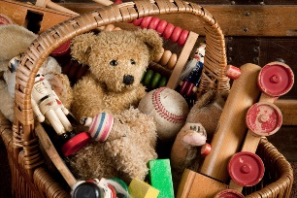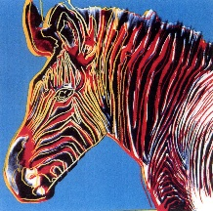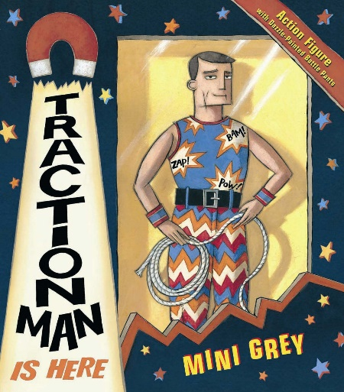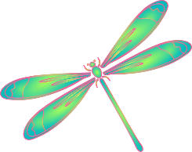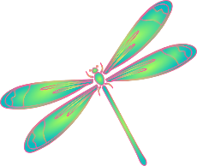

**English**

We will be reading ‘Traction Man is here’ by Mini Grey. From this we will create our own diary entry from the perspective of Traction Man.

We will also be looking at poetry written about toys.

**Key Question:**

What did the children who used to attend our school play with?

**RE**

We will be exploring the question:

Why does Christmas matter to Christians?

**Computing**

We will be exploring the creation of media through digital photography.

**PE**

In PE we will be improving our balance and coordination in gymnastics and creating a group performance

**Art**

We will be exploring pop art and creating our own prints inspired by Andy Warhol.

**DT**

We will be creating, making, and designing a vehicle for Traction Man to travel in.

**Maths**

Year 1 will focus on:

* Addition and Subtraction
* Shape

Year 2 will focus on:

* Addition and Subtraction
* Shape

**Activate Curiosity**

We will become Historians, looking back to the Victorian Era when our school was first built, and exploring toys throughout history.

**The Old Toy Shop**

**Dragonflies – Year 1 and 2**

**Autumn Term 2**

**Science**

We will be exploring different everyday materials, their uses and their properties.

We will look at the materials of various toys, and how these have changed through history.

**History**

In History we will:

* Use a historical source to find out about toys and games in the past.
* Investigate, describe and compare old and new toys.
* Learn about chronology and create a timeline of toys, games and artefacts.
* Make their own toy museum with the facts and information they have learnt.

ACTIVATE CURIOSITY DISCUSS AND DISCOVER LET’S DO IT DIG DEEPER SHARE, CELEBRATE AND REFLECT