**Maths**

In maths, we will be looking at place value. We will be looking at numbers up to 1000, exploring their hundreds, tens and ones. We will also work on ordering, comparing numbers as well as being able to count in multiples. We will practice our rounding skills and work with negative numbers too.

**PSHE**

Our topic for PSHE this half term is ‘being me in my world.’

**Science**

The children will be learning all about electricity. We will be learning how to construct a simple series circuit whilst identifying and naming its basic parts, including, cells, wires, bulbs, switches, and buzzers. We will also learn to recognise some common conductors and insulators.

**History**

Our history focus this half term is ‘The Stone Age.’ We will be exploring how life has changed since those times, making comparisons, and looking at where this came in the chronology of key historic periods. Excitingly, we will be using ‘outdoor learning/ forest school’ to facilitate our learning in this area.

**Art**

This half term, we will be enhancing our drawing skills to create portraits. We will be taking inspiration from the artist ‘Frida Kahlo’. From this, we shall be creating our very own art exhibition for you to come and enjoy!

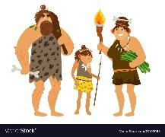



**RE**

In our RE sessions, we will be delving into the question ‘What do Christians learn from the creation story?’ We will also look at why Christians might pray to god, say sorry and ask for forgiveness.

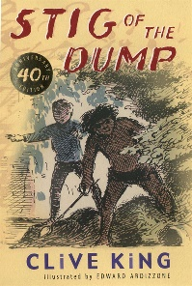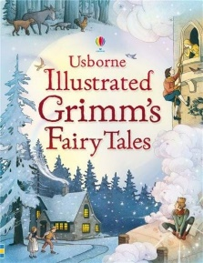

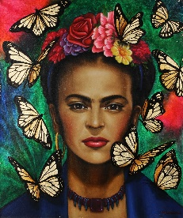

**English**

Initially, we will be looking at the Grimms Brother’s Fairy Tales in our English lessons. We will particularly be focusing on the story ‘Tom Thumb’ to write our own alternative ending. During this unit, we will be looking at the features of traditional tales and the language they use. In terms of grammar, we will be recapping sentence structure and punctuation as well as learning about the four main sentence types, the use of speech marks, adverbs and apostrophes.

**Languages**

We will be learning greetings and numbers in Spanish.

**Music** We will use the song ‘Let your spirit fly to’ explore the dimensions of music.

**PE**

We will be learning the rules and skills required for basketball in PE.

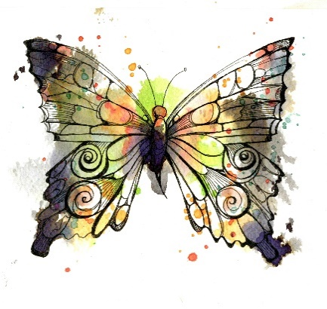

**Butterflies Planning Map – Autumn Term 1**

**Computing**

We will be looking at computing systems and networks.

**Butterflies - Autumn 1 Homework**

|  |  |  |
| --- | --- | --- |
| **Each day** | **Each week** | **This half term** |
| * Please read your book each day – even if it is just a few pages. This is the most important activity you can do! * Bug Club books need to be read at least twice for fluency. * If you are on Accelerated reader, you can quiz on this website either at home or when you come to school the next morning:   <https://global-zone61.renaissance-go.com/welcomeportal/2236638> or scan the code …  Young boy reading a book with imagination 614400 Vector Art at Vecteezy | * Practice your weekly spelling list ready for a check each Friday. * Times tables rockstars (This is particularly important for the year 4s who will be taking the government times tables check this year). | Challenge: What story does your cave drawing tell? Can you tell us a story to accompany your picture?  Success criteria:   * A clear beginning, middle and end * Adjectives for description * Capital letters and full stops   **Please bring in your homework so that we can celebrate your efforts!** |