**Science**

Light! The children will learn about how we see, shadows, reflection, and refraction. The children will also learn how light travels and how this enables us to see objects. We will make a periscope, finding out about mirrors and the angle of reflection and the effects of bending light. There will be opportunities for collaboration and working scientifically in an experiment investigating refection.

**Maths**

For most of this half-term, the children will be learning about fractions. The children will build upon their knowledge of what a fraction is as well as look at using multiplication and division to find equivalent fractions. Both year groups will add and subtract fractions with the same denominator and denominators that are multiples of the same numbers. Year 6 will move on to adding and subtracting fractions where the denominators are not multiples of the same numbers. Both year groups will multiply fractions by integers, with Year 6 then moving on to multiply a fraction by a fraction. Year 6 will also explore dividing fractions and drawing their learning together by using any four operations with fractions.

**PSHE**

Our theme this half-term is *Celebrating Difference*.

**History**

This half term we will be focussing on World War 2 and deepening our understanding of the events that unfolded. We will also be looking at the impact that WW2 had on local places**.**

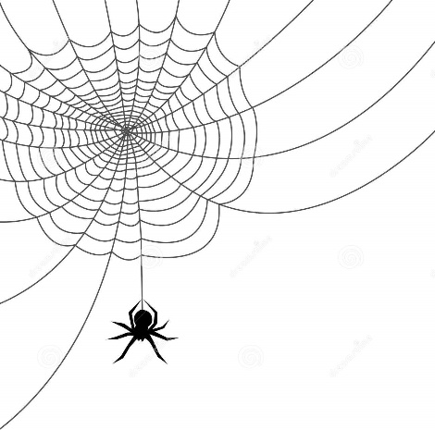

**RE**

Carrying on from last half-term, the children will be looking at the religion of Hinduism and will try to answer the question *Why do Hindu’s want to be good?*

**Art**

This half-term we will be studying the work of the artist Henry Moore.

**Music**

Classroom Jazz will be the theme for this half term.

**PE**

Gymnastics will be the focus for this half-term. Children will focus on performing, refining and developing advanced movements.

**English**

The History theme of World War II will be running through our English lessons this half-term. We start with a diary entry using the beautiful text *My War Diary, by Flossie Albright* (Marcia Williams) to support the children’s writing. Our second text will cover the genre of letter writing. The children will learn to incorporate some powerful and new content within their writing to develop their sentences, including: figurative language (symbolism), flashbacks, (trigger and transition) and amplification.

**Computing**

Children will get the chance to create their own webpage through exploring what is needed to do this safely and creatively.

**Spiders Planning Map – Autumn Term 2**