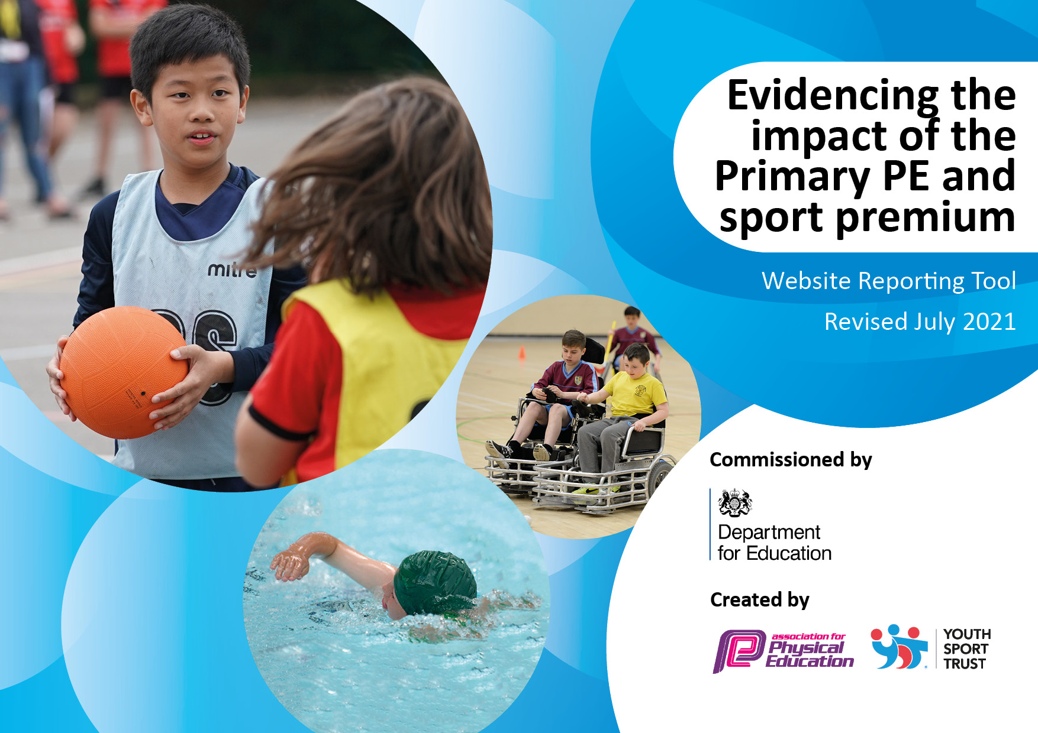
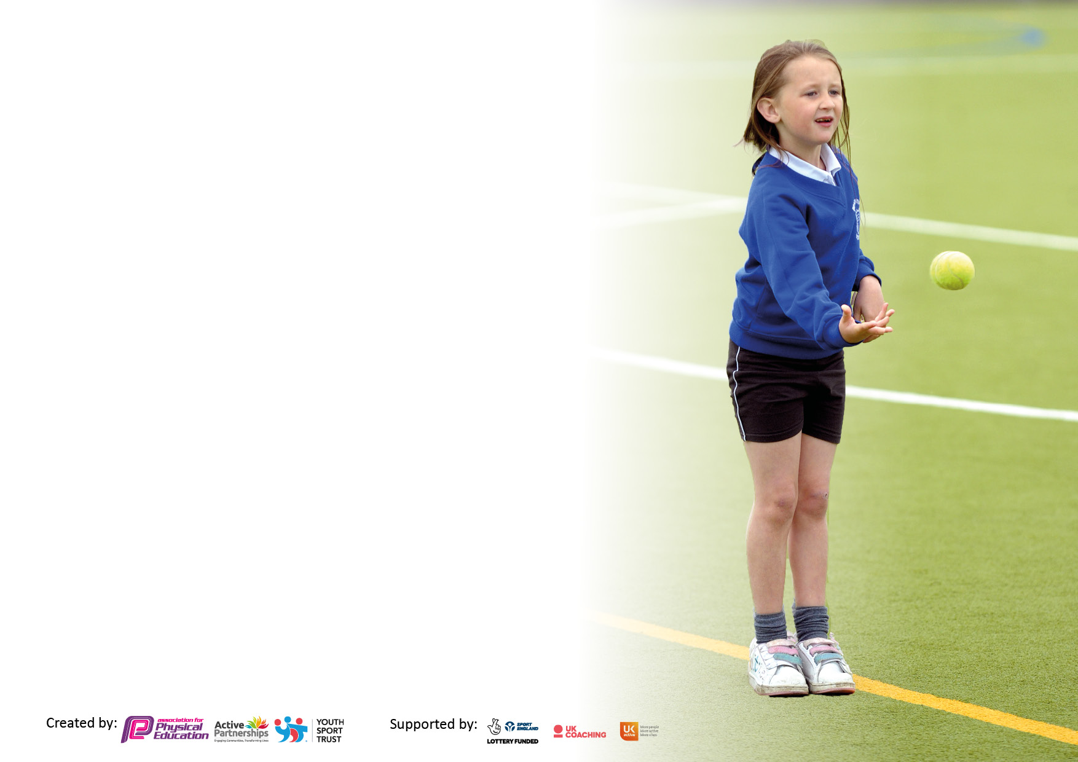

It is important that your grant is used effectively and based on school need. The Education Inspection Framework makes clear there will be a focus on ‘whether leaders and those responsible for governors all understand their respective roles and perform these in a way that enhances the effectiveness of the school’.

Under the Quality of Education Ofsted inspectors consider:
Intent - Curriculum design, coverage and appropriateness
Implementation - Curriculum delivery, Teaching (pedagogy) and Assessment
Impact - Attainment and progress

To assist schools with common transferable language this template has been developed to utilise the same three headings which should make your plans easily transferable between working documents.

Schools must use the funding to make additional and sustainable improvements to the quality of Physical Education, School Sport and Physical Activity (PESSPA) they offer. This means that you should use the Primary PE and sport premium to:

- Develop or add to the PESSPA activities that your school already offer
- Build capacity and capability within the school to ensure that improvements made now will benefit pupils joining the school in future years
- The Primary PE and sport premium should not be used to fund capital spend projects; the school’s budget should fund these.

Pleasevisitgov.ukfortherevisedDfEguidanceincludingthe5keyindicatorsacrosswhichschoolsshoulddemonstrate animprovement.Thisdocumentwillhelpyoutoreviewyourprovisionandtoreportyourspend.DfEencouragesschools to use this template as an effective way of meeting the reporting requirements of the Primary PE and sport premium.

We recommend you start by reflecting on the impact of current provision and reviewing the previous spend.

Schools are required to publish details of how they spend this funding, including any under-spend from 2019/2020, as well as on the impact it has on pupils’ PE and sport participation and attainment. All funding must be spent by 31st July 2022.

We recommend regularly updating the table and publishing it on your website throughout the year. This evidences your ongoing self-evaluation of how you are using the funding to secure maximum, sustainable impact. Final copy must be posted on your website by the end of the academic year and no later than the 31st July 2021. To see an example of how to complete the table please click HERE.
Created by: Supported by:
Action Plan and Budget Tracking
Capture your intended annual spend against the 5 key indicators. Clarify the success criteria and evidence of impact that you intend to measure to evaluate for pupils today and for the future.

Academic Year: 2022-23 | Total fund allocated: 16,970 | Date Updated: 16/12/2022
Key indicator 1: The engagement of all pupils in regular physical activity – Chief Medical Officers guidelines recommend that primary school pupils undertake at least 30 minutes of physical activity a day in school |  |  |  | Percentage of total allocation:
Intent | Implementation |  | Impact
Your school focus should be clear what you want the pupils to know and be able to do and about  what they need to learn and to  consolidate through practice: | Make sure your actions to achieve are linked to your intentions: | Funding allocated: | Evidence of impact: what do pupils now know and what can they now do? What has changed?: | Sustainability and suggested next steps:
Increase daily physical activity by engaging all students in daily active playtimes and during the school day.  Play leaders training & uniform | Equipment purchased so students of all ages have access to a range of different physical activities during these times. | £400  £200

Key indicator 2: The profile of PESSPA being raised across the school as a tool for whole school improvement |  |  |  | Percentage of total allocation:
Intent | Implementation |  | Impact
Your school focus should be clear what you want the pupils to know and be able to do and about  what they need to learn and to  consolidate through practice: | Make sure your actions to achieve are linked to your intentions: | Funding allocated: | Evidence of impact: what do pupils now know and what can they now do? What has changed?: | Sustainability and suggested next steps:
Specialist PE staff to raise profile of PE and school sport to drive forward improvement in the subject and whole school community.  Organise a school community sport day to celebrate sport as a key part of school life.  Regular competitions to raise profile of the subject  Purchase specialist resources to improve quality of sport across the curriculum.  Increase the number of after school provision. | The school has employed a specialist PE teacher.  Activity providers will deliver activities for the children.  Every class will represent their school in a festival/competition at least once over the year.  KS2:  - Rugby  - Cross country  - Football  - Handball  - Striking & Fielding  - Athletics  - Dance  KS1 & EYFS:  - Multi-skills  - Athletics | See KS1  £700 + PTFA support  £150 towards venue hire  £400  £250

Key indicator 3: Increased confidence, knowledge and skills of all staff in teaching PE and sport |  |  |  | Percentage of total allocation:
Intent | Implementation |  | Impact
Your school focus should be clear | Make sure your actions to | Funding | Evidence of impact: what do | Sustainability and suggested
what you want the pupils to know | achieve are linked to your | allocated: | pupils now know and what | next steps:
and be able to do and about | intentions: |  | can they now do? What has
what they need to learn and to |  |  | changed?:
consolidate through practice:
Regular professional development for all teaching staff, promoting higher quality teaching of PE. | Employed school PE teacher to deliver regular training for staff.  Class teachers work with PE specialist to assess students and have regular feedback about their own delivery of PE. | £10,007

Key indicator 4: Broader experience of a range of sports and activities offered to all pupils |  |  |  | Percentage of total allocation:
 |  |  |  | 11%
Intent | Implementation |  | Impact
Your school focus should be clear | Make sure your actions to | Funding | Evidence of impact: what do | Sustainability and suggested
what you want the pupils to know | achieve are linked to your | allocated: | pupils now know and what | next steps:
and be able to do and about | intentions: |  | can they now do? What has
what they need to learn and to |  |  | changed?:
consolidate through practice:
Diverse PE curriculum offering students a range of sports and activities. New activities offered as part of 2022-23 curriculum  Give all students the opportunity to experience outdoor and adventurous activities  Give children the chance to learn a total new activity  Increase opportunities for disadvantaged pupils and families. | Our PE curriculum is designed by specialist PE teacher. This gives students the chance to learn 12 sports and activities over a 2-year cycle.  - Year 5 & 6 surfing trip  - Year 3 & 4 -  - Year 1 & 2 -  Book a martial arts instructor.  Sailing family memberships paid for by the school. | Included in KI3 cost (£10,007).  £500  £500  £500  £500  Total: £2000  £500  £350

Key indicator 5: Increased participation in competitive sport |  |  |  | Percentage of total allocation:
 |  |  |  | 7%
Intent | Implementation |  | Impact
Your school focus should be clear | Make sure your actions to | Funding | Evidence of impact: what do | Sustainability and suggested
what you want the pupils to know | achieve are linked to your | allocated: | pupils now know and what | next steps:
and be able to do and about | intentions: |  | can they now do? What has
what they need to learn and to |  |  | changed?:
consolidate through practice:
Offer students trust-wide competitions to every student in the school from EYFS-year 6. | Students have competed in the following events:  - KS2 tag rugby  - KS2 cross country  - EYFS & KS1 multi-skills  - Year 5 & 6 Handball  - KS2 Football  - Year 3 & 4 striking and fielding.  - KS2 tennis  - Athletics | £2000 - transport

Total Funding Projected spend: £16,957

Signed off by
Head Teacher:
Date:
Subject Leader: | Matt Tanner
Date:
Governor:
Date:

