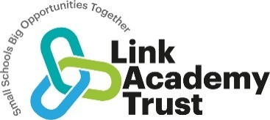
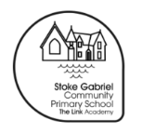 Stoke Gabriel Primary School
History Curriculum Plan

Our curriculum statements are designed to be used as a supportive tool to plan teaching and learning across our school. The key skills are derived from the National Curriculum and spilt into individual year groups to support a progressive approach and mixed age classes.

The study of history involves engaging pupils in investigating questions about people and events in the past in order to enable them to better understand their lives today and for a future as more informed and enlightened citizens. Through the study of history pupils also develop a wide range of critical thinking skills, which enable them to understand the contested nature of knowledge and to distinguish between ‘fact’ and subjectivity when it comes to reaching conclusions and making judgements about the past. With this in mind, at Stoke Gabriel, we are proud of our History Curriculum which is:
• Aspirational: Our high-expectations in History teaching and learning enables our children to fulfil their individual potential, cultivates their natural curiosity about the past and enables our children to appreciating the value of History as a subject in the 21st century.
• Engaging: Our children develop their historical perspective through enquiry-based learning. The concepts ‘continuity & change’, ‘cause & consequence’, ‘similarity & difference’ and ‘significance’ underpin these, with children asking increasingly nuanced questions, exploring how the past is constructed from a range of sources, appreciating why interpretations of history vary and understanding how knowledge of the past is constructed by historians.
• Logical, Broad and Balanced: Learning and enquiries have been purposefully selected and sequenced to support chronological understanding, to be relevant to our local community and to meet the guidance and expectations of the Early Years Foundation Stage and the National Curriculum. To further learning about people, events and periods of the past, key historical concepts, such as ‘monarchy’ or ‘trade’, are taught within historical contexts and are revisited and developed through our curriculum.
• Progressively More Challenging: Children build upon prior learning and encounter more complex subject knowledge using increasingly sophisticated critical thinking skills. In doing so children develop a secure subject knowledge, achieve a deeper understanding key concepts and appreciation for the discipline - what it means to work historically.
• Inclusive: All children are entitled to our History Curriculum, with personalisation and differentiation being used to extend and support individual children as necessary. Our children leave our schools with a chronologically secure historical knowledge rooted in their mental timeline; with a clear understanding of how historians have reached their interpretations of history and how the world we live in today has been shaped by our predecessors and could, ultimately, be shaped by their actions.

Vocabulary
Children’s command of vocabulary is fundamental to learning and progress across the curriculum. Vocabulary is developed actively, building systematically on pupil’s current knowledge and deepening their understanding of etymology and morphology (word origins and structures) to increase their store of words. Simultaneously, pupils make links between known and new vocabulary, and discuss and apply shades of meaning. In this way, children expand the vocabulary choices that are available to them. It is essential to introduce technical vocabulary which define each curriculum subject. Vocabulary development is underpinned by an oracy culture and a tiered approach. High value is placed on the conscious, purposeful selection of well-chosen vocabulary and appropriate sentence structure to enrich access to learning and feed into written work across the curriculum.

EYFS – Reception History Vocabulary – This is just a starting point for teachers to amend according to the needs of their children.
Chronological vocabulary: adult, after, afternoon, baby, before, calendar, child, day, future, grandparent, life-cycle, long ago, memory, morning, new, next, night, old, parent, seasons, past, present, time, then, yesterday .
Disciplinary vocabulary: change, compare, different, fossil, museum, order, sequence, similar, what, when, where, who, why,
Substantive Concepts: belief, buildings (architecture), celebration, conflict, farming (agriculture), equality, invent, job, king, money, migrate, power, queen, religion, royal, tradition, technology, transport, tourism.

KS1 Key History Vocabulary – This is just a starting point for teachers to amend according to the needs of their children

Chronological vocabulary: century, childhood, chronological, decade, future, great-grand parent, lifetime, living-memory, modern, month, period, recent, past, present, timeline, tomorrow, week, year Disciplinary vocabulary: archaeologist, artefact, cause, change, compare, consequence, continue, diary, evidence, first-hand, historian, history, impact, interpretation, opinion, reason, sequence, significance, similar, source, version Substantive concepts: agriculture, architecture, belief, city, conflict, communication, democracy, education, empire, explorer, inequality, government, invasion, invention, law, lifestyle, manufacture, material, medicine, military, monarchy, occupation, parliament, power, protest, religion, rights, slavery, society, technology, trade, transport, tradition, war

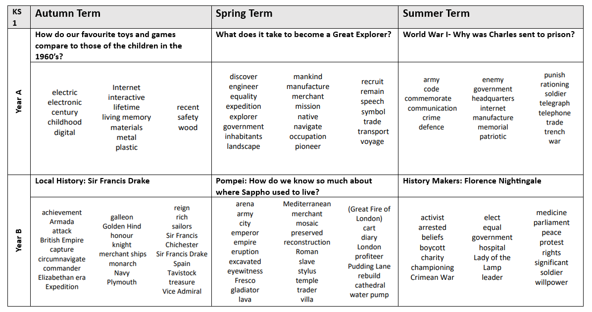

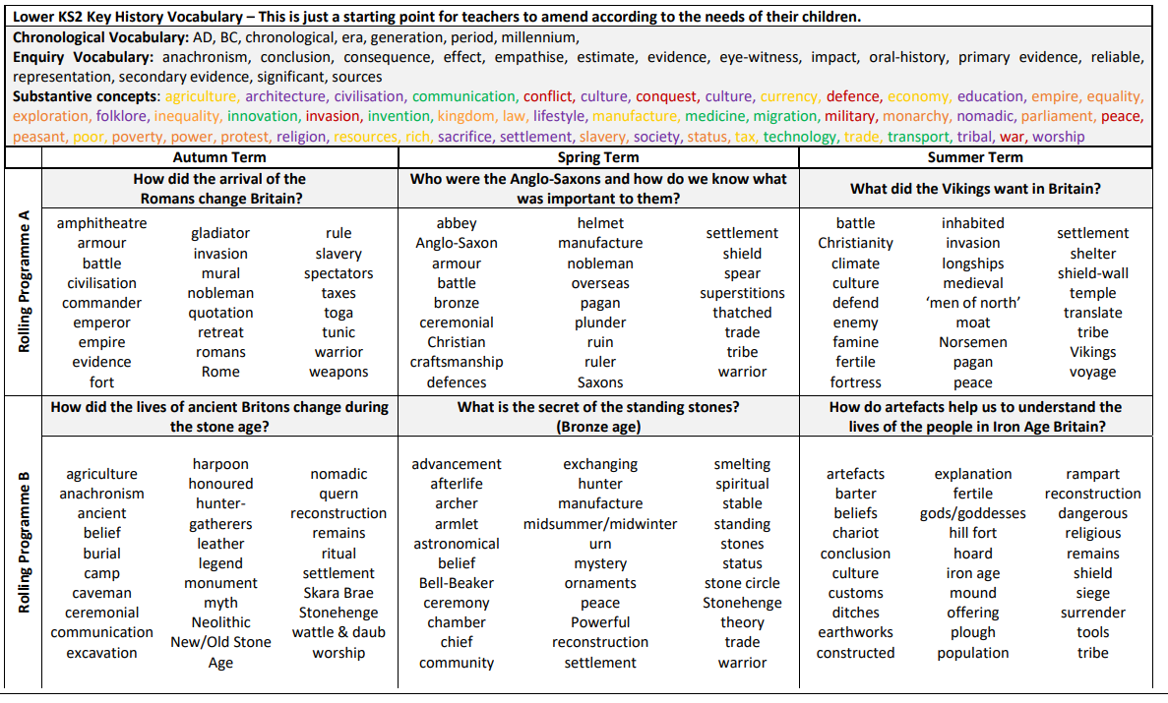
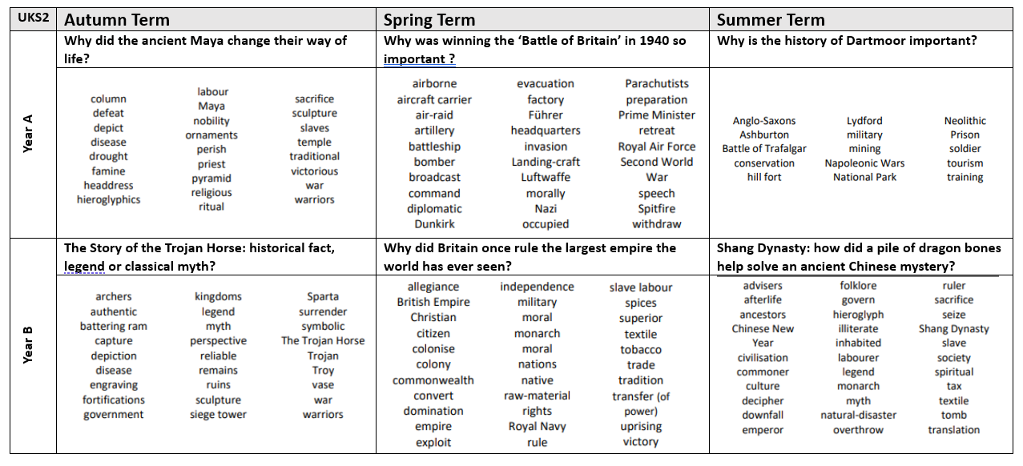
Curriculum Organisation and Information
Our History curriculum enables all learners to develop their historical perspective progressively as they move through each stage of their education, by acquiring chronologically secure historical knowledge through historical enquiry. This knowledge of people, events and periods, can only be meaningfully acquired when historical terms, including key substantive concepts such as ‘empire’, ‘invasion’ and ‘trade’, are taught in historical context and developed throughout our curriculum. The historical concepts ‘continuity & change’, ‘cause & consequence’, ‘similarity & difference’ and ‘significance’ underpin our enquiry-based learning, with children asking age-appropriate and increasingly nuanced questions, exploring how the past is constructed from a range of sources, appreciating why ‘interpretations‘ of history vary and, ultimately, understanding how knowledge of the past is constructed by historians.
The Early Years Foundation Stage (EYFS)
Children in Reception develop an early understanding of history through the knowledge and skills outlined in the EYFS’s area of learning called ‘Understanding of the World’ (UotW) – ‘Past and Present’. However, as with all learning in the early years, children’s understanding of the passing of time permeates into all areas of the EYFS curriculum and is enriched by both specific teaching and broader classroom practises, with opportunities to further understanding of the past and present being made as appropriate to do so - including spontaneous child-led learning moments! Reception teachers plan engaging lessons that link to their inspiring half-termly topics to develop children’s historical knowledge chronological understanding and emergent enquiry skills. Lessons introduce topic-specific vocabulary, include both adult-led and play-based learning activities and nurture the ‘characteristics of effective learning’. Learning is embedded in the children’s real-life experiences, the experiences of people they know and in the context of the wide variety of texts (stories, non-fiction, rhymes and poems) shared in class. Children explore the meaning of new vocabulary, use language to imagine and recreate roles and experiences in play situations and learn to use past, present and future terminology accurately. They learn to use tenses correctly and, supported by our ‘Oracy’ approach, children develop their ability to clearly articulate their ideas and begin to justify their thinking. The language rich learning environment is purposefully provisioned to further learning and provides opportunities for children to explore and compare aspects of the past with those of the present day. At all times children are encouraged to be curious, to observe closely and to discover for themselves – key skills which are fundamental to the development of our little historians!
Key Stage One and Two
Children in Key Stage One and Key Stage Two must receive the full entitlement of the National Curriculum (NC) and we ensure this is delivered through our enquiry-led history curriculum which is based on the expertise of the Connected History units, which we have carefully crafted into two-year rolling programme to meet the needs of our mixed-age classes. We have purposefully selected and sequenced topics, through and across key stages, to build cumulatively on prior learning and to progressively further skills development. History learning is organised into half-termly topics (that alternate with Geography) which allows students to ‘dive-deeper’ into their learning and limits the time between history topics - helping children to retain their learning. Opportunities for meaningful cross-curricular learning are made whenever appropriate, particularly during half-terms where history is not discretely taught to revisit skills and reinforce key knowledge. Our history topics are based around an engaging ‘big question’ (shaped by a second-order concept) which captures children’s interests and gives purpose to learning. Rather than giving children all the answers through their topic learning, children embark on a journey of exploration! At the beginning of each topic children share questions that they would like to find answers to, and teachers always encourage children to ask their own questions understanding that curiosity is central to historical enquiry. Supported by our whole-school Oracy approach, children learn to articulate their ideas and to justify their thinking with opportunities for partner, group and whole-class discussion and debate being planned into each topic. Studying history in this way inspires children’s curiosity, it encourages them to ask critical questions and develops their characteristics of effective learning. Teachers use the Link Academy agreed Medium Term planning document to plan a sequence of learning based on their ‘big question’, referring to the Connected History guidance and the Progression in Key Skills document below and the historical terms banks above. Each topic has a clear learning journey, with an ‘elicitation task’ at the start of a topic to identify a child’s prior knowledge. Children are then taught the knowledge and skills they need to answer the over-arching ‘big question’ in small manageable steps, with each lesson having a clear curriculum linked learning objective which is shared with the children - making it clear what and how children are expected to learn. Teachers can begin a lesson with a flash-back to previous or key learning, in order to address misconceptions, reinforce learning and to support long-term memory connections – helping children retain knowledge. Lessons include a range of teaching approaches, activities are tailored to challenge and support children appropriately and provide opportunities for children to work independently, with a partner or in a group. History lessons are tailored to the needs of each child, with teachers using ‘assessment for learning’ strategies to swiftly pinpoint children’s next steps in learning to identify those who require more support and those who can be challenged to ‘dig deeper’ - maximising progress. Learning is adapted and personalised to ensure children with SEND or EAL are able to access the full curriculum and have an equal opportunity to take part in every aspect of the History curriculum. Teachers capture ‘creative’ learning using a SWAY document and promptly mark recorded learning in line with our marking policy, ensuring feedback is purposeful, furthering history learning and addressing misconceptions. Each classroom has a topic display (which includes key vocabulary) and topic related books available. Topics may include a ‘hook’ to provide memorable learning opportunities, with teachers organising trips to museums and cultural sites, guest speakers, immersion days, ICT and physical resources/artefacts are used where possible. The subject leader monitors standards through ‘book looks’ including Sway & Tapestry, pupil conferencing, looking at planning, learning walks and discussions with staff and supports teachers with subject knowledge and continued professional development for example by leading staff meetings and making staff aware of new resources. Beyond curriculum specific learning the subject-lead also oversees the celebration and commemoration of annual significant and local historical events such as Armistice Day, Bonfire Night or the Queen’s Platinum Jubilee throughout the school.
The National Curriculum
Pupils are taught:
In Key Stage 1:
• changes within living memory. Where appropriate these should be used to reveal aspects of change in national life
• events beyond living memory that are significant nationally or globally [for example the Great Fire of London, the first aeroplane flight or events commemorated through festivals or anniversaries]
• the lives of significant individuals in the past who have contributed to national and international achievements. Some should be used to compare aspects of life in different periods
• Significant historical events, people and places in their own locality: Sir Francis Drake
In Key Stage 2:
• changes in Britain from the Stone Age to the Iron Age.
• the Roman Empire and its impact on Britain.
• Britain’s settlement by Anglo-Saxons and Scots.
• The Viking and Anglo-Saxon struggle for the Kingdom of England to the time of Edward the Confessor.
• a local history study – ‘Dartmoor’
• a study of an aspect or theme in British history that extends pupils’ chronological knowledge beyond 1066 – The Mayan Civilisation
• the achievements of the earliest civilizations – an overview of where and when the first civilizations appeared and a depth study of one of the following: Ancient Sumer; The Indus Valley; Ancient Egypt; The Shang Dynasty of Ancient China
• Ancient Greece – a study of Greek life and achievements and their influence on the western world
• a non-European society that provides contrasts with British history – one study chosen from: early Islamic civilization including a study of Baghdad c. AD 900; Mayan civilization c. AD 900; Benin (West Africa) c. AD 900-1300
Progression of Key Skills
Key skills

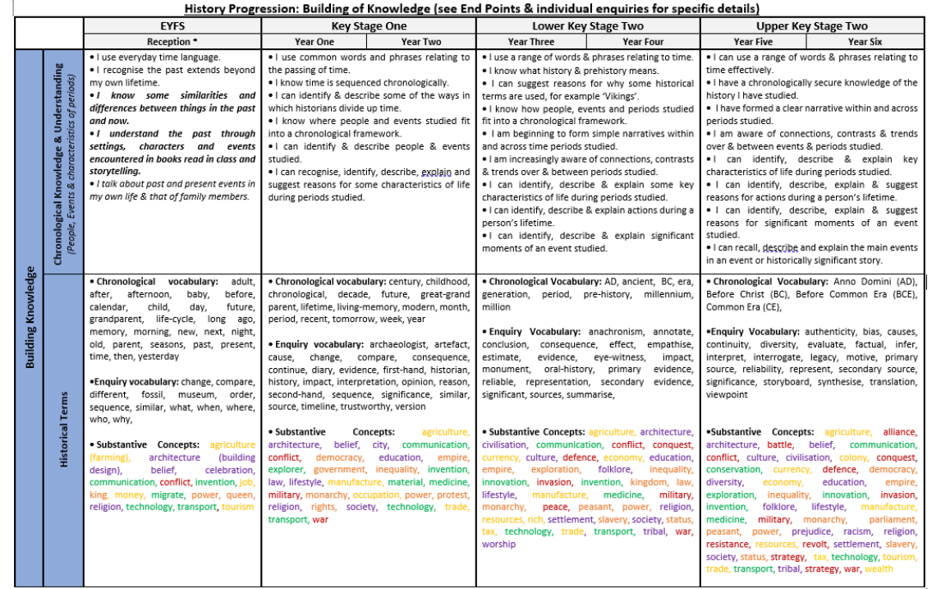

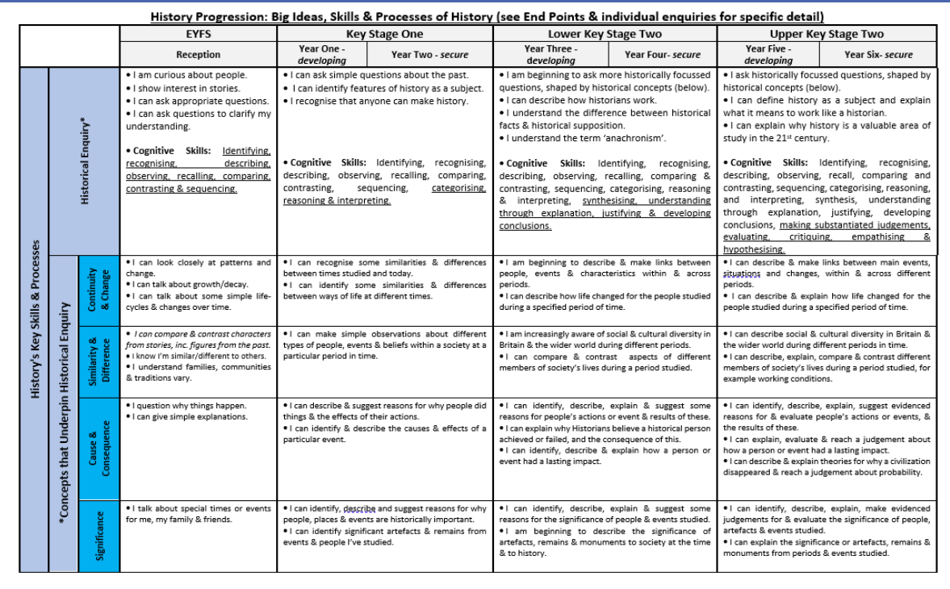
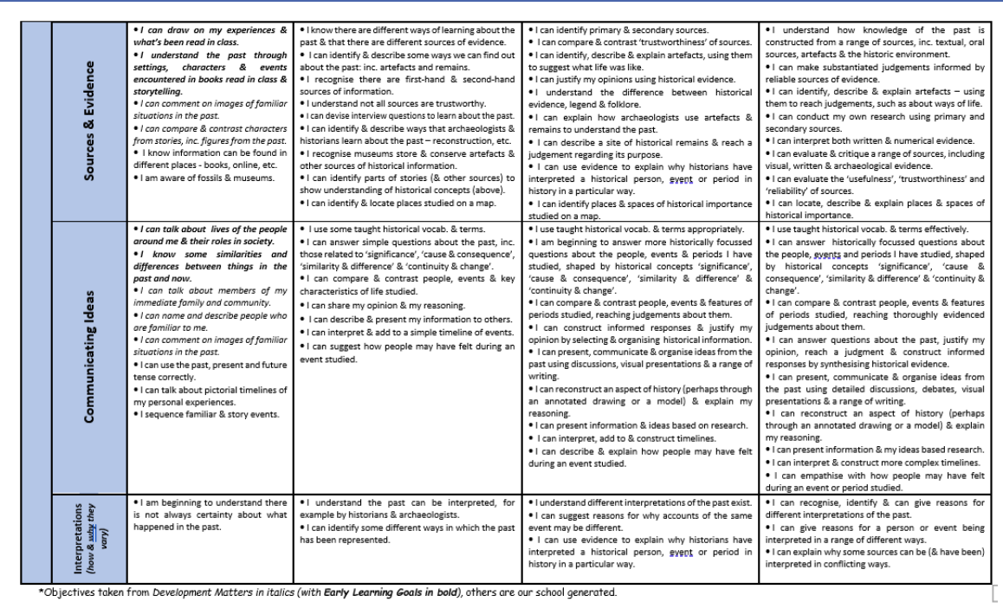
In order to assess impact - a guide
Teachers are responsible for the regular assessment of their pupils against key skills to judge the impact of teaching and learning in History. Teachers look at the learning journey of each unit studied being aware of what the children need for their next learning and what they can take from prior learning. Units will therefore begin with an elicitation task either individual or whole class to judge prior knowledge; a KWL (know, want to learn, learnt) grid could be used and may be completed independently in books or constructed with the teacher. Children’s progress is monitored against National Curriculum expectations and key skills. Judgement is informed through use of children’s books dialogue class scrapbooks evidence on Sway and Tapestry and AFL pieces. Teachers need to be clear on how the children will show their learning through a presentation art work or extended writing for example providing opportunity for pupils to communicate their learning in a variety of ways. There is an expectation that History learning in books will be the same quality as that in English books. Marking and feedback in History should be the same standard as marking/feedback within other learning across the curriculum including English. The focus for spelling corrections is on History vocabulary and the expectation is that children who are ARE will spell these correctly throughout their History writing.

