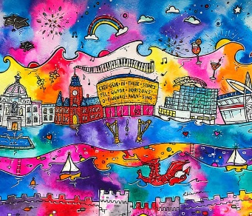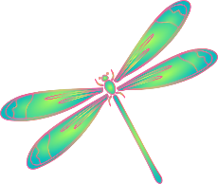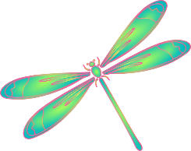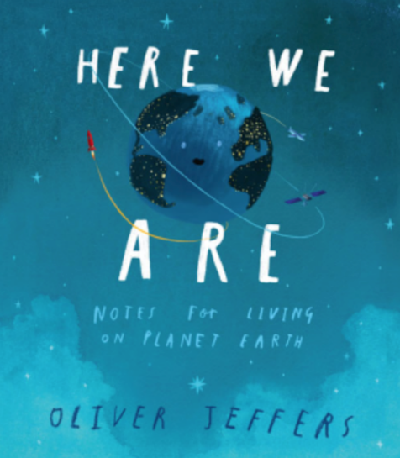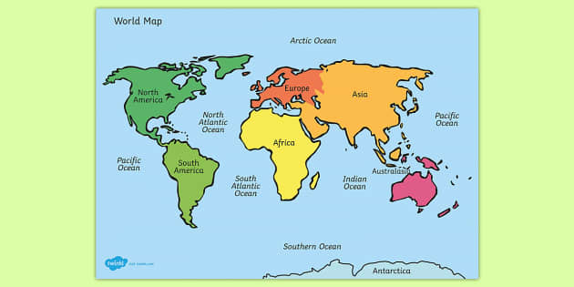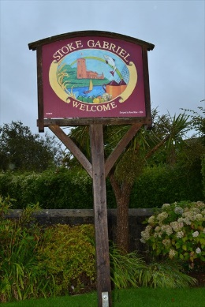

**RE**

We will be exploring the question:

What makes some places sacred to believers?

**Computing**

We will be exploring computing systems and networks, the IT around us, and how to use it safely.

**HERE WE ARE – STOKE GABRIEL**

**Art**

We will be looking at the artist Rhiannon Roberts, with a particular focus on tone, colour and line techniques. This is with the aim to produce our own piece of landscape art.

**Dragonflies – Year 1 and 2**

**Autumn Term 1**

**PE**

In PE we will be learning about invasion games, and how work as a team to defend and attack a zone.

**Science**

We will be learning how to think like a scientist, whilst we explore how things change throughout the year, seasonal celebrations and seasonal changes.

Key Questions:

Where is ‘here’?

What is it like ‘here’?

**Maths**

Year 1 will focus on:

-Place value to 10

-Addition and Subtraction to 10

Year 2 will focus on:

-Place value to 100

-Addition and Subtraction

**Geography**

In Geography we will:

* Explore ‘Here We Are’ by Oliver Jeffers
* Use aerial photographs, globes, maps and atlases
* Learn about Earth’s continents and oceans
* Learn about human and physical features
* Explore compasses
* Use observational and fieldwork skills to explore the school and village
* Create our own maps

**English**

We will be exploring ‘Here We Are: Notes for Living on Planet Earth’ by Oliver Jeffers.

We will use this text to create our own notes on how we should live and take care of Stoke Gabriel.

**Activate Curiosity**

We will become geographers, exploring the world around us through maps, imagery and being outdoors.

ACTIVATE CURIOSITY DISCUSS AND DISCOVER LET’S DO IT DIG DEEPER SHARE, CELEBRATE AND REFLECT